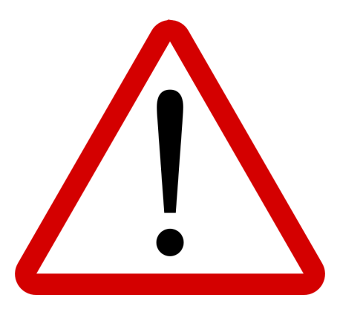
Community Drug Alert
~ DATE ISSUED ~
COMMUNITY NAME
Describe substance here. (ie: down sold in blue flaps, blue powdered down etc.)
Include drug checking results if you have them any.
Add a photo if available.
Use large font.
This substance has been connected to drug poisonings (overdoses) in the area.
FOR YOUR SAFETY:
No matter what or how you use (smoking, snorting, injecting), take steps to prevent overdose:
- Get your drugs checked – find locations at drugchecking.ca
- Avoid mixing.
- Use with others around or at an Overdose Prevention Site (OPS).
- Start with a small amount.
- Carry naloxone and know how use it.
- Get the LifeGuard App - lifeguardh.com
- Call 211 or visit bc211.ca to find services near you

Alert issued by: INSERT Name of Agency

Please take down alert by: DATE/one week from date issued

